# **Recursive Algorithms**

Here are some practice exercises you can do for recursion. Assignment will consist of one or more of these problems (ask your teacher) but all can be completed for your own expertise:

1) A Binary search is done on a sorted list by finding the middle element of the list, determining which side of the list the element you are searching for is on and then repeating the process with the remaining half of the list. Write a recursive solution to this problem.

2) A palindrome is a word that can be read forward or backwards, for example “radar” and “Hannah”. Phrases can be used as well (assume spaces are ignored) for example “Do geese see God” or “Tahitti hat” or “Never odd or even”. Write a recursive function that determines if a string is a palindrome.

3) You are given a rectangular floor that is to be tiled with square tiles. The tiles come in a variety of sizes, but they all measure in some power of two: 1, 2, 4, 8, etc. A 5x6 space can be tiled with 30 of the smallest tile, but the minimum number of tiles required is only 9. Refer to the pattern below.

The input file **DATA3.txt** will contain 5 lines, a pair of integers 1 <= N, M <= 10000, separated by a space.

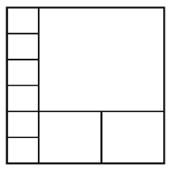The output file **OUT3.txt** will contain 5 lines, the minimum number of tiles necessary to exactly cover the N by M space.

|  |  |
| --- | --- |
| Sample Input:  10 5  1000 1001  21 13  9999 888  345 1277 | Sample Output:  14  1358  42  4065  2046 |